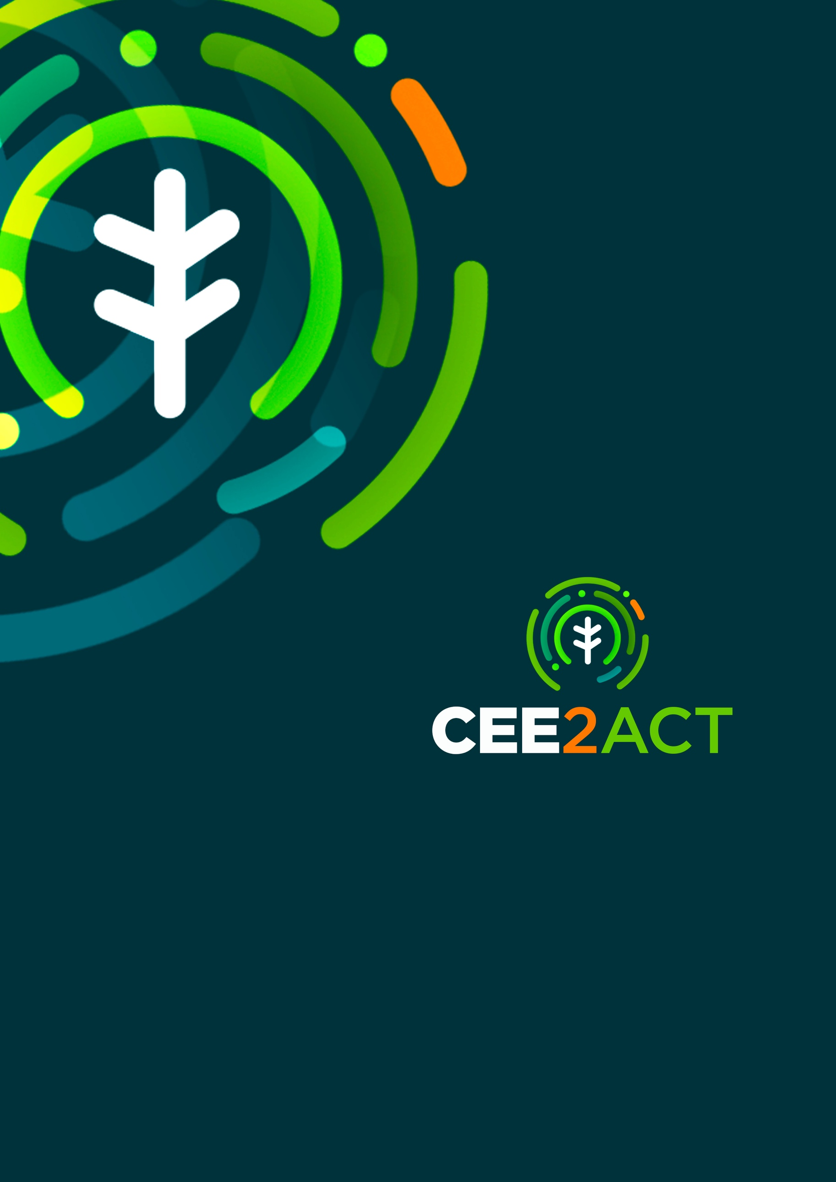
Empowering the Central and
Eastern European Countries to Develop
Bioeconomy Strategies and Action Plans

Empowering the Central and
Eastern European Countries to Develop
Bioeconomy Strategies and Action Plans
Press Release
SEPTEMBER 2022

Press release

CEE2ACT launched to support 10 Central and Eastern European countries in developing circular bioeconomy strategies

On 13-14 September 2022, representatives of 17 European organisations from 17 countries gathered in Budapest at the kick-off meeting of the CEE2ACT project, funded under the European Union’s Horizon Europe Research and Innovation programme.

The European Green Deal has set Europe on its path to being the first climate-neutral continent by 2050 and achieving a green transition that is just, fair and inclusive. One of the seven core pathways to deliver this climate neutrality is the bioeconomy. The 2018 update to the EU bioeconomy strategy highlighted the relevance of developing national bioeconomy strategies and action plans to deploy a sustainable and circular bioeconomy across Europe, considering economic, social and environmental aspects.

To date, there are still Member States, including many from Central and Eastern Europe (CEE) that do not have a national bioeconomy strategy and action plan despite their high biomass resource base and new bioeconomy potential. However, there are relevant regional initiatives supporting bioeconomy in Central and Eastern European countries.

According to the progress report on the EU bioeconomy strategy (published on 9 June 2022), Bulgaria is classified among the EU member states which do not have national strategies for bioeconomy, but in which other policy initiatives and documents dedicated to the bioeconomy have been undertaken and developed. In practice, Bulgaria has developed sectoral and regional strategies for the development of bioeconomy, such as: Strategy for strengthening the role of the agricultural sector in the bioeconomy (MAFF), 2019, Strategy for the transition to circular economy, 2021-2027, Strategy for the development of the bioeconomy in Stara Zagora region, 2017, etc.

The objective of CEE2ACT is to empower countries in Central Eastern Europe (Hungary, Bulgaria, Croatia, Czechia, Poland, Romania, Slovakia, Slovenia,) and beyond (Greece, Republic of Serbia) to develop circular bioeconomy strategies and action plans, through knowledge transfer and innovative governance models, to achieve better-informed decision-making processes, societal engagement, and innovation, building on the practice of experienced countries (Austria, Belgium, Finland, Germany, Netherlands, Spain, Sweden).

Knowledge transfer and inspiration in creative formats that address the motivations, needs and knowledge gaps of each CEE2ACT target country will be realised through CEE2ACT National Bioeconomy Hubs. A bottom-up approach will be applied throughout the project activities, tackling specific knowledge gaps and shortcomings of the top-down conventional approach, building closer interconnections between actors across public institutions, private sector, industry, energy, SMEs, feedstock providers (e.g., waste, side streams, farmers, foresters, fishermen), academia and research, NGOs, and Civil Society Organisations in the target countries.
To achieve this, a baseline assessment will be carried out, and stakeholder engagement activities will be implemented ensuring the active participation of all relevant stakeholders. Digital solutions for sustainable governance will be created, supporting the exchange of best practices on technology transfer, and building the capacities of the stakeholders to develop bottom-up bioeconomy strategies.

The findings will be used and disseminated through practical tools, guidelines, and policy recommendations to support beneficiary countries to develop flexible and inclusive bioeconomy strategies and action plans, boosting societal engagement in the countries’ transition toward a circular bioeconomy.

About CEE2ACT

Geographical scope: Austria, Belgium, Bulgaria, Croatia, Czechia, Finland, Germany, Greece, Hungary, Netherlands, Poland, Romania, Serbia, Slovakia, Slovenia, Spain, Sweden.

Overall budget and funding source: EUR 3.9 million. HORIZON-CL6-2021-Governance-01-10 Horizon Europe Coordination and Support Action project. This project has received funding from the European Union’s Horizon Europe Research and innovation programme under grant agreement N°101060280.

Duration: 36 months (1 September 2022 – 31 August 2025)

Coordinator: María Beatriz Rosell, Senior Project Manager, Geonardo Environmental Technologies Ltd., Email: maria.beatriz.rosell@geonardo.com

Media & Communications: Nathalie Bargues, Project Manager, Greenovate! Europe, Email: n.bargues@greenovate-europe.eu

Upcoming website: www.cee2act.eu

Social media channels: LinkedIn and Twitter

